Experiment 10: write a Python program to implement the A* (A-Star) Search Algorithm

Aim
To write a Python program to implement the A* (A-Star) Search Algorithm for finding the shortest path in a graph.

Algorithm
- Define the graph and heuristic values.
- Initialize the open list with the start node.
- Select the node with the lowest f(n) = g(n) + h(n).
- Expand the selected node and calculate the cost of its neighbors.
- Add unvisited neighbors to the open list.
- Repeat the process until the goal node is reached.
- Display the shortest path.

Program
graph = {
'A': [('B', 1), ('C', 3)],
'B': [('D', 3), ('E', 5)],
'C': [('F', 2)],
'D': [],
'E': [('G', 2)],
'F': [('G', 4)],
'G': []
}

heuristic = {
'A': 6,
'B': 4,
'C': 3,
'D': 3,
'E': 2,
'F': 1,
'G': 0
}

open_list = [('A', 0)]
visited = []
parent = {'A': None}

while open_list:
open_list.sort(key=lambda x: x[1] + heuristic[x[0]])
node, cost = open_list.pop(0)

if node == 'G':
path = []
while node:
path.append(node)
node = parent[node]
print("Shortest Path:", " -> ".join(path[::-1]))
break

visited.append(node)

for neighbour, weight in graph[node]:
if neighbour not in visited:
parent[neighbour] = node
open_list.append((neighbour, cost + weight))

Output
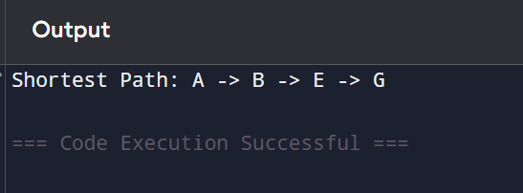

Result
Thus, the Python program to implement the A* Search Algorithm was executed successfully, and the shortest path from the source node to the goal node was obtained.

